DEPARTMENT OF BASIC SCIENCES AND ISLAMIAT
University of Engineering and Technology, Peshawar

Paper : Complex Variables (BSI-362)
Mid-Term Examination Summer-2020
(Computer System Engineering)
Time Allowed: 2 hours Max Marks: 20
Note: Attempt all questions:

Question No 1 (CLO-1 ,C1, PLO-1 3+4+3)

(a) Find all roots in the complex plane 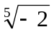

(b) Find “a” so that the given function is harmonic and find a harmonic conjugate
(c) Find all solutions in the complex plane 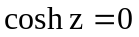

Question No 3 (CLO-2, C3, PLO-2, 3+3+4)

(a) Find the line integral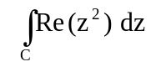 C: is the shortest path from t0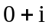to
(b) Find the integral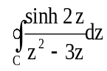 C consists of 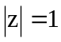clockwise
(c) Find the integral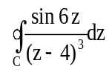
C consists of 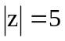( counterclockwise) and 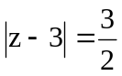 clockwise.

